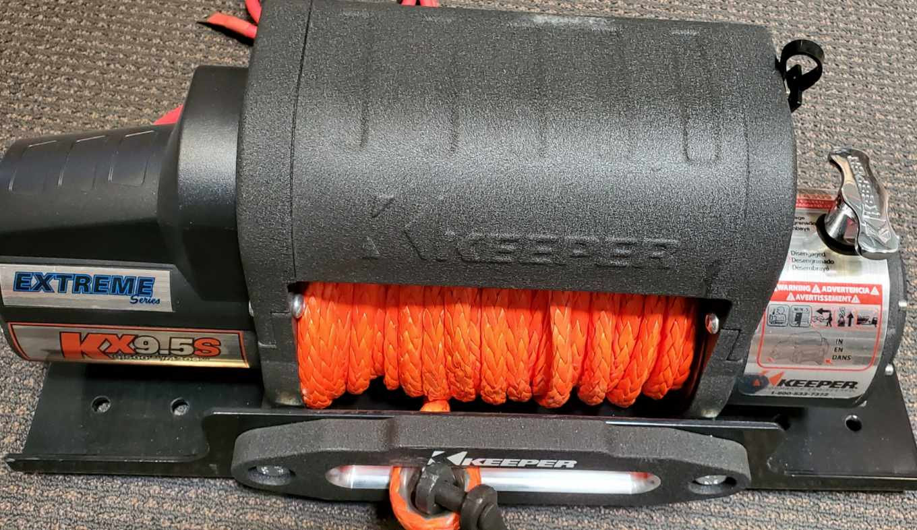

For KX9500 and KX9500S Winches Remove top cover by removing 6 Philip screws. There are 3 screws in the front and 3 screws in the back side.

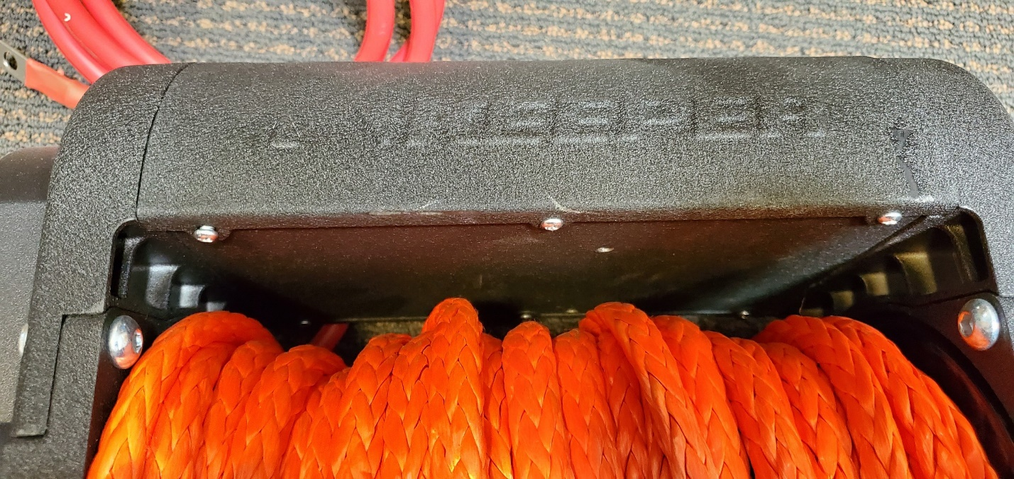

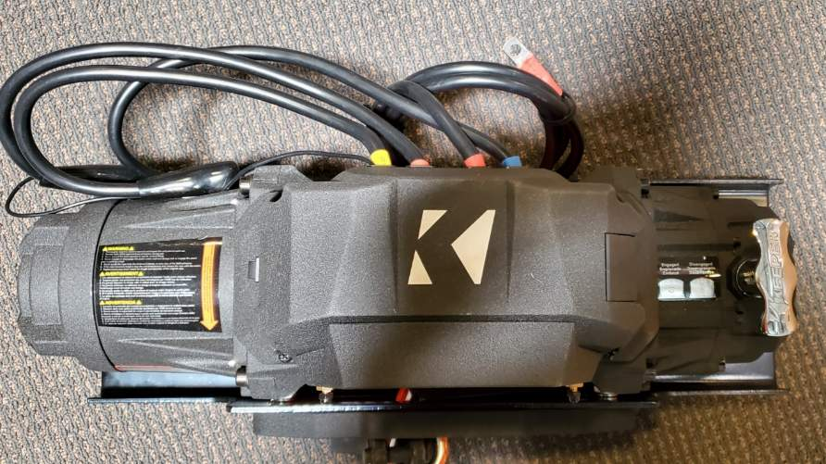
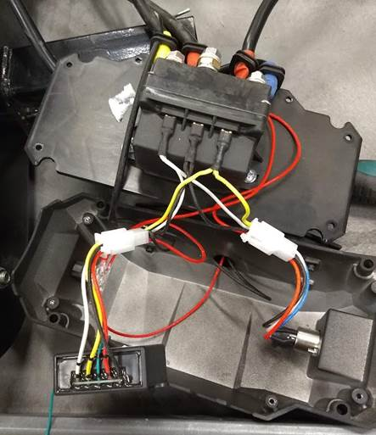
You only need to replace the antenna
For KX9500E, KX9500ES and KX9500EH Winches Remove top cover by removing 4 Philip screws. There are 2 screws in the front top and 2 screws in the back top.

